Habitats

Sort out the sentences

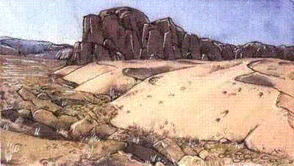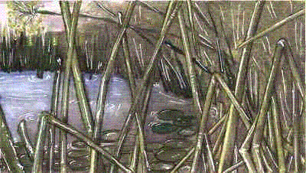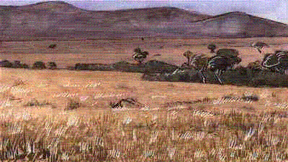

Sort out the jumbled words to make sentences about habitats.

- need don’t animals Usually water desert in that live a much.

- nice salty and Sea is is so it to not water drink.

- and covered of snow time the Antarctica is Most in ice.

- Antarctica sea. fish feed on Animals that live in from the

- very change places much temperatures do during the temperate year. no In

- pond temperate in areas is good A a place for animals plants to live and.

- temperate to have Trees forest leaves, and berries provide food for in flowers animals.

- the equator. found rainforests near Tropical are

- High is and air temperature called ‘humid’. damp often

- Cattle good grasslands. buffalo have a savannah life in and the

